**Deborah Caplow**

**Carrington, Leonora**

Born: Clayton Green, Chorley, Lancashire—1917; Died: Mexico City—2011

Leonora Carrington was a painter, sculptor, poet and novelist who drew on mythology, fantasy and the occult to create images of a dreamlike world. She grew up in a wealthy family in England, educated by governesses, and was deeply influenced by the fairy tales her Irish nanny told her. Her parents sent her to convent schools, and although they expected her to become a socialite, they allowed her to attend Mrs. Penrose’s Academy of Art in Florence, Italy. Once back in London in 1936, Carrington enrolled in **Amédée Ozenfant**’s Academy of Fine Arts. She attended the 1936 International Surrealist Exhibition in London, and was impressed by the work of **Max Ernst**, whom she met the following year. Carrington moved to France in 1937 to be with Ernst and joined the Surrealist circle in Paris; however, the two of them were separated at the beginning of Second World War, and Carrington made her way to Mexico City, where she joined a group of exiled Surrealists. She based her *Self Portrait* of 1938 on Celtic myths, and after moving to Mexico, she included Pre-Columbian imagery in many of her works. In later years she divided her time between New York and Mexico City. She received the Order of the British Empire in 2000.

In spite of her father’s opposition to her art career, and her parents insistence that she be presented at the English court when she was seventeen, early on Carrington decided to study painting seriously. Carrington lived with Ernst in Paris, and later in the small town of Saint Martin d’Ardèche in the South of France, where they lived and worked until 1940, creating sculptures and paintings together. At this time Carrington painted *Portrait of Max* *Ernst* and her better-known *Self-Portrait*, both of which demonstrate her imaginative, magical-realist approach to her subjects. The image of the horse in her self-portrait refers to her childhood love of horses and Celtic myth; other elements of the painting, such as the lactating hyena and the chair with booted feet, are open to interpretation, as Carrington worked in a Surrealist mode, drawing from the unconscious in a process of free association.

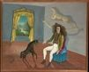

Leonora Carrington, *Self-Portrait* (also called *The Inn of the Dawn Horse*), oil on canvas, oil on canvas, 650×813 mm, 1938 (New York, Metropolitan Museum of Art, The Pierre and Maria-Gaetana Matisse Collection, 2002)

<http://www.metmuseum.org/collections/search-the-collections/492697>

When the Second World War broke out, Ernst, a German citizen, was arrested and put into an internment camp as an enemy alien. He was freed, but imprisoned again when the Nazis invaded France. Carrington fled to Spain, where she suffered a nervous breakdown and entered a mental hospital in Santander through arrangements made by her parents. The experience was traumatic; she was given powerful drugs and shock treatment, and she later wrote an account of this time called *Down Below*. She eventually escaped and made her way to Lisbon. She married Mexican diplomat and writer Renato Leduc, who had offered to help her leave Europe; together, they travelled first to Paris, then New York, where they lived for a year, and finally to Mexico in 1942. By this time Ernst had married Peggy Guggenheim, and although he and Carrington met again in Paris and New York, their altered relationship was painful and difficult for both of them.

Once in Mexico City, Carrington settled into the community of Surrealists in exile, forming close friendships with painter **Remedios Varo**, photographer Kati Horna, and artist José Horna, as well as many other Surrealist artists and writers, refugees like herself. She ended her marriage of convenience with Leduc in 1942, and in 1946 married Hungarian refugee, Imre (Chiqui) Weisz, a friend and former darkroom assistant of photojournalist Robert Capa. They had two children, and Carrington balanced motherhood with her life as a painter for many years. She considered her relationship with Varo to be the most important friendship of her life; they painted and wrote together, seeing one another almost daily until Varo’s death in 1963. In the 1940s the wealthy English Surrealist artist and writer Edward James, who had strong ties to Mexico, became Carrington’s major patron, promoting her work and organizing a solo exhibition for her at the Pierre Matisse Gallery in New York in 1947. He also became a life-long friend and purchased many of her paintings.

Committed to feminism and working independently of male Surrealists, Carrington participated in Mexico’s Women’s Liberation Movement in the 1970s. Her work was influenced by Hieronymus Bosch and other Northern Renaissance painters, as can be seen in her 1947 *Temptation of Saint Anthony*, set in a strange landscape, with references to Bosch’s painting of the same subject.

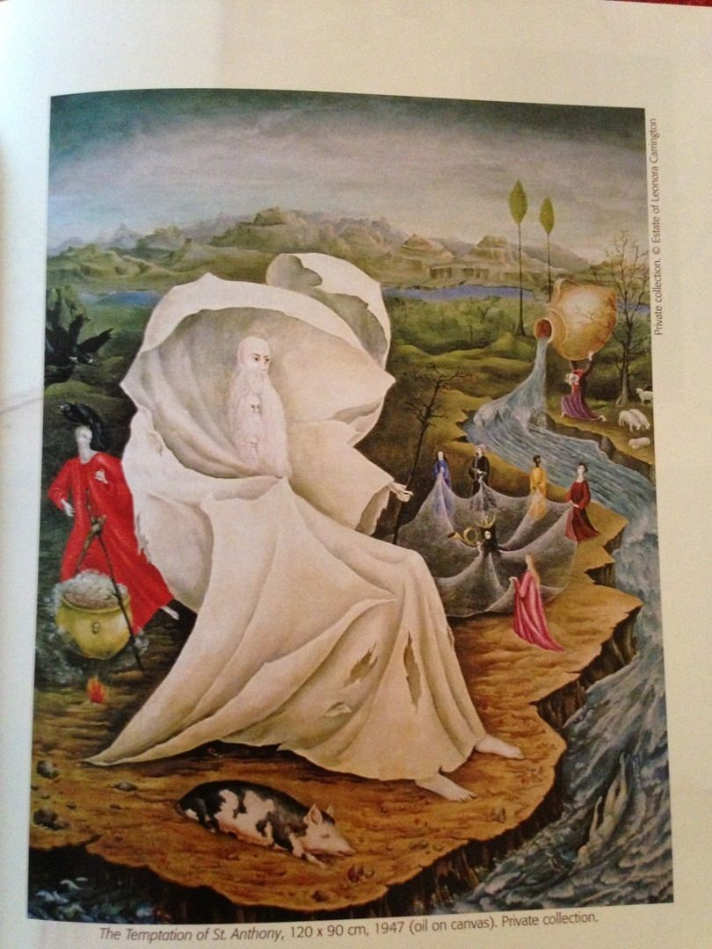

Leonora Carrington, *The Temptation of Saint Anthony*, oil on canvas, 1947.

http://www.leocarrington.com/paintings-pinturas.html

Carrington’s work also reflects her studies in Surrealism and world religions, mythology, shamanism, alchemy and the occult, but true to Surrealist principles, she refused to interpret her work. Although she lived in Mexico for much of her life, her themes were universal, with only a few exceptions. In 1963 she received a government commission to paint a mural for the National Museum of Anthropology. For this mural, *El mundo mágico del los Mayas*, she blended her own distinctive style of magical realism with Mayan themes, based on intensive study of the history and culture of the Maya of Chiapas in Southern Mexico.

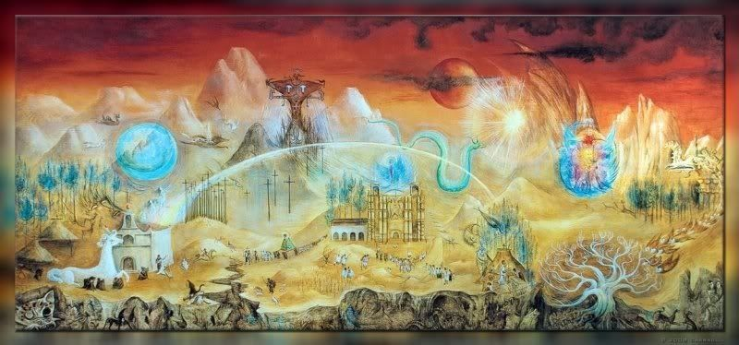

Leonora Carrington, El mundo mágico de los Maya

http://www.leocarrington.com/paintings-pinturas.html

She lived and worked in Mexico City and New York until she died at age ninety-four. In Carrington’s later years, from the 1990s to 2011, she created large-scale bronze sculptures of fantastical beings, many of which were displayed in Mexico City in 2008 on the Paseo de la Reforma and at the Galería Juan Soriano in the Centro Nacional de las Artes in 2013. She continued to work almost up to her death in 2011.

**Further Reading:**

Aberth, S. (2004) *Leonora Carrington: Surrealism, Alchemy and Art*, Aldershot Hampshire: Lund Humphries.

Ades, D. (1914) *Leonora Carrington,* New York: Distributed Art Publishers.

Chadwick, W. (1986). "Leonora Carrington: Evolution of a Feminist Consciousness". *Women's Art Journal* **7** (1): 38.

Chadwick, W. (1985) *Women Artists and the Surrealist Movement*, New York: Thames and Hudson.

Gaensbauer, D. (1994) "Voyages of Discovery: Leonora Carrington's Magical Prose", *Women's Studies* **23** (3).

Kunny, C. (1996) “Leonora Carrington's Mexican Vision” Art Institute of Chicago Museum Studies, **22** (2).

*Leonora Carrington—The Mexican Years, 1943-1985* (1998). Albuquerque: University of New Mexico Press.

Poniatowska, E. (2011) *Leonora*, Mexico City, Seix Barral.

Van Raay, S., Moorhead, J. and Arcq, T. 2010 *Surreal Friends: Leonora Carrington, Remedios Varo and Kati Horna*, Lund Humphries in association with Pallant House Gallery.

**Works By:**

*Down Below* (1983) New York: Black Swan Press.

*The House of Fear: Notes from Down Below* (1988), New York: Dutton.

*The Hearing Trumpet* (1976), London: Virago.

*The Seventh Horse and Other Tales* (1988), New York: E.P. Dutton.

*The Stone Door* (1977), New York: St. Martin's Press.

**List of Artworks:**

*Portrait of Max Ernst*, oil on canvas, 1939.

*Self-Portrait* (*The Inn of the Dawn Horse*), oil on canvas, 1938,

*The Giantess* (The Guardian of the Egg), tempera on wood panel, ca. 1947.

*Night Nursery Everything,* oil on canvas, 1947.

*The Temptation of Saint Anthony*, oil on canvas, 1947

*The Juggler*, oil on canvas, 1953

*El mundo mágico de los Mayas*, Mural, casein on Masonite, 1963.

*Grandmother Moorhead’s Aromatic Kitchen*, oil on canvas, 1975.